**Kol Simcha Torah Gazette**

**For parsha eikev 5785**

Volume 9 Issue 46 (Whole #460) 22 Menachem Av 5785/ August 22, 2025

**Printed L’illuy nishmas Nechama bas R’ Noach, a”h**

For a free subscription, please forward your request to [***keren18@juno.com***](mailto:keren18@juno.com)

***Past emails can be found on the website ShabbosStories.com under Brooklyn Torah Gazette***

**17 Facts You Should Know About King David**

**By** [**Yehuda Altein**](https://www.chabad.org/search/keyword_cdo/kid/17830/jewish/Altein-Yehuda.htm)

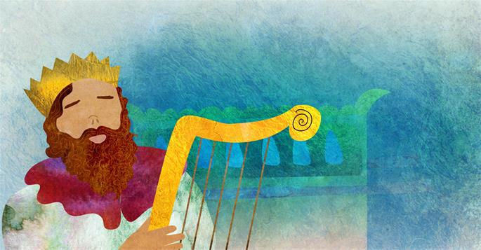

***Art by*** [***Sefira Lightstone***](https://www.chabad.org/3159160)

*King David is one of the most beloved and well-known figures in all of Jewish history. Over the course of his life, he wore many hats—devoted shepherd, fearless warrior, pious Torah scholar, and gifted poet and musician. Read on for 17 facts about this remarkable and inspiring leader.*

**1. His Story Is Told in the Book of Samuel**

David’s life story is told in the Book of Samuel and again in the Book of Chronicles. It’s full of twists, turns, and dramatic moments that make it hard to put down. But beyond the action and adventure, his life is packed with powerful lessons that continue to guide and inspire us today.

**2. He Started Life as a Shepherd**

David was the youngest of seven (or eight[1](javascript:doFootnote('1a6985122');)) sons born to Jesse (Yishai), a righteous man[2](javascript:doFootnote('2a6985122');) from Bethlehem. Unlike his older brothers, who engaged in more “important” endeavors, he was sent to care for the sheep. But he didn’t treat it like a simple chore—he cared for the flock with such dedication that G‑d saw he was fit to one day shepherd the Jewish people.[3](javascript:doFootnote('3a6985122');)

**3. His Name Is Second in a Series of Palindromes**

*Fun fact:* In Hebrew, the names Jesse (ישי), David (דוד), and Nathan (נתן)—one of David’s sons—are all palindromes!

**4. Ruth Was His Great-Grandmother**

You might know the story of Ruth, the Moabite woman who left everything behind to become part of the Jewish people. She married Boaz, a Jewish leader, and became the great-grandmother of King David.[4](javascript:doFootnote('4a6985122');) Ruth’s noble qualities were passed down to David, who personified her loyalty, humility, and courage.

**5. He Was Anointed by the Prophet Samuel**

When King Saul didn’t follow [G‑d](https://www.chabad.org/library/article_cdo/aid/433240/jewish/God.htm)’s instructions to destroy Amalek, G‑d sent the prophet Samuel to anoint a new king. Samuel went to Jesse’s home in Bethlehem, expecting to choose one of the older sons. But G‑d told him not to judge by appearances—the youngest son, David, was the one destined to be king. Samuel anointed him with oil, though it would be several years before David officially adopted his new role.[5](javascript:doFootnote('5a6985122');)

**6. He Killed a Giant With a Slingshot**

The Jewish people were threatened by the Philistines, whose champion was the giant Goliath. While everyone else was too afraid to fight him, young David stepped forward with nothing but a slingshot and strong faith in G‑d. With one well-aimed stone, he brought down the giant—and became a hero overnight.[6](javascript:doFootnote('6a6985122');)

**7. He Was a Fearless Warrior**

David was brave long before he fought Goliath. As a shepherd, he fought off a lion and a bear with his bare hands to protect his sheep.[7](javascript:doFootnote('7a6985122');) Later, as a general in King Saul’s army,[8](javascript:doFootnote('8a6985122');) he led the fight against Israel’s enemies. Even after becoming king, he continued to lead with courage, securing peace and safety for his people.

As a reward for his daring exploits, King Saul gave David his daughter Michal’s hand in marriage.[9](javascript:doFootnote('9a6985122');)

**8. King Saul Pursued Him**

David’s growing popularity aroused King Saul's jealousy. As his envy grew, Saul tried to kill David, forcing him to flee with Saul in hot pursuit. There were times when the role was reversed, and David had the opportunity to harm Saul, but he chose not to, out of deep respect for Saul’s role as G‑d’s anointed king.[10](javascript:doFootnote('10a6985122');)

**9. His Enemy’s Son Was His Closest Friend**

Even though Saul was against him, David shared a deep friendship with Saul’s son, Jonathan. The two made a pact of loyalty and love that lasted a lifetime.[11](javascript:doFootnote('11a6985122');) The Sages of the Mishnah point to their bond as the perfect example of selfless love: “True love, not dependent on any outside factor—that’s the love of David and Jonathan.”[12](javascript:doFootnote('12a6985122');)

**10. He Ruled from Hebron and Then Jerusalem**

After Saul died, David became king, ruling with fairness and compassion for 40 years. At first, he ruled from Hebron—home of our patriarchs—for seven and a half years. He later moved his residence to [Jerusalem](https://www.chabad.org/library/article_cdo/aid/4246466/jewish/Jerusalem.htm), which has remained the eternal capital of the Jewish people ever since.[13](javascript:doFootnote('13a6985122');)

**11. He Laid the Groundwork for the Temple**

David chose Jerusalem because he knew it was the future home of the Holy Temple. Although he wanted to build the Temple himself, G‑d told him no—he had fought too many battles. Instead, David’s son Solomon, who represented peace, would be the one to build it. Still, David did everything he could to help, gathering materials like stone, iron, copper, and cedar wood for the holy project.[14](javascript:doFootnote('14a6985122');)

**12. He Was an Accomplished Musician**

David was a talented harpist. Before things turned sour between them, King Saul would invite David to play for him, and the music would calm his troubled spirit.[15](javascript:doFootnote('15a6985122');) Even after becoming king, David kept his harp nearby. According to tradition, the wind would stir its strings at midnight, waking him to study [Torah](https://www.chabad.org/library/article_cdo/aid/1426382/jewish/Torah.htm).[16](javascript:doFootnote('16a6985122');)

**13. He Composed Psalms**

David is perhaps best known as the author of *Tehillim* ([Psalms](https://www.chabad.org/library/bible_cdo/aid/15770/jewish/Tehillim-Psalms.htm)), a book of poetic prayers expressing his deep emotions and powerful faith.[17](javascript:doFootnote('17a6985122');) His Divinely-inspired words continue to uplift Jews everywhere, who turn to Psalms in times of hope, fear, gratitude, or sorrow. Sections of Psalms are recited as part of the daily prayers, and many follow a cycle of completing the entire book each month.

**14. He Was a Torah Scholar**

David wasn’t only a king—he was also a serious Torah scholar. He used every free moment to study Torah, finding strength and comfort in its teachings. As he wrote in Psalm 119:92: “Had Your Torah not been my delight, I would have perished in my affliction.”

David used his knowledge to help others. When women came to him with questions of Jewish law relating to family purity, he did whatever was necessary to assist them—never feeling that any task was beneath his dignity.[18](javascript:doFootnote('18a6985122');)

**15. Two of His Sons Rebelled Against Him**

Sadly, David faced trouble from his own family. His son Absalom became popular and tried to usurp the throne, forcing David to leave Jerusalem. In the end, thanks to a spy David placed in Absalom’s camp, the rebellion was stopped and peace was restored.[19](javascript:doFootnote('19a6985122');) Toward the end of David’s life, his son Adoniahu tried to crown himself as king, leading David to declare his appointment of Solomon as his successor.[20](javascript:doFootnote('20a6985122');)

**16. His Yahrzeit Is on Shavuot**

King David died at the age of 70 on the holiday of [Shavuot](https://www.chabad.org/library/article_cdo/aid/111377/jewish/Shavuot-2026.htm),[21](javascript:doFootnote('21a6985122');) in the year 2924 (837 BCE). The Talmud tells us that the Angel of Death couldn’t get to him while he was learning Torah, so it waited until he was briefly distracted before taking his life.[22](javascript:doFootnote('22a6985122');) But in many ways, David still lives on: [*“David melech Yisrael chai v’kayam—David, King of Israel, lives forever.”*](https://www.chabad.org/library/article_cdo/aid/6975508/jewish/What-Is-the-David-Melech-Yisrael-Song-Doing-in-Kiddush-Levanah.htm)

**17. Moshiach Is His Descendant**

David began a royal dynasty that continued until the destruction of the First Temple. His descendants remained leaders even in exile—through the exilarchs in Babylon and sages in the Land of Israel.[23](javascript:doFootnote('23a6985122');) And when Moshiach comes, he’ll be a descendant of King David too—someone who will reflect David’s courage, righteousness, and deep love of Torah.[24](javascript:doFootnote('24a6985122');) May we merit to welcome him very soon!

**Footnotes**

[1.](https://www.chabad.org/library/article_cdo/aid/6985122/jewish/17-Facts-You-Should-Know-About-King-David.htm" \l "footnoteRef1a6985122) See [I Samuel 16:11](https://www.chabad.org/library/bible_cdo/aid/15845/jewish/Chapter-16.htm#v11) and commentary of Metzudat David there.

[2.](https://www.chabad.org/library/article_cdo/aid/6985122/jewish/17-Facts-You-Should-Know-About-King-David.htm" \l "footnoteRef2a6985122) See [Bava Batra 17a](https://www.chabad.org/torah-texts/5456458/The-Talmud/Bava-Batra/Chapter-1/17a). [3.](https://www.chabad.org/library/article_cdo/aid/6985122/jewish/17-Facts-You-Should-Know-About-King-David.htm#footnoteRef3a6985122) Shemot Rabbah 2:2. [4.](https://www.chabad.org/library/article_cdo/aid/6985122/jewish/17-Facts-You-Should-Know-About-King-David.htm#footnoteRef4a6985122) [Ruth 4:17](https://www.chabad.org/library/bible_cdo/aid/16456/jewish/Chapter-4.htm#v17). [5.](https://www.chabad.org/library/article_cdo/aid/6985122/jewish/17-Facts-You-Should-Know-About-King-David.htm#footnoteRef5a6985122) [I Samuel 16:1](https://www.chabad.org/library/bible_cdo/aid/15845/jewish/Chapter-16.htm#v1)–13.

[6.](https://www.chabad.org/library/article_cdo/aid/6985122/jewish/17-Facts-You-Should-Know-About-King-David.htm" \l "footnoteRef6a6985122) [I Samuel 17:1](https://www.chabad.org/library/bible_cdo/aid/15846/jewish/Chapter-17.htm#v1)–54. [7.](https://www.chabad.org/library/article_cdo/aid/6985122/jewish/17-Facts-You-Should-Know-About-King-David.htm#footnoteRef7a6985122) [I Samuel 17:34](https://www.chabad.org/library/bible_cdo/aid/15846/jewish/Chapter-17.htm#v34)–35. [8.](https://www.chabad.org/library/article_cdo/aid/6985122/jewish/17-Facts-You-Should-Know-About-King-David.htm#footnoteRef8a6985122) [I Samuel 18:5](https://www.chabad.org/library/bible_cdo/aid/15847/jewish/Chapter-18.htm#v5). [9.](https://www.chabad.org/library/article_cdo/aid/6985122/jewish/17-Facts-You-Should-Know-About-King-David.htm#footnoteRef9a6985122) [I Samuel 18:20](https://www.chabad.org/library/bible_cdo/aid/15847/jewish/Chapter-18.htm#v20)–27.

[10.](https://www.chabad.org/library/article_cdo/aid/6985122/jewish/17-Facts-You-Should-Know-About-King-David.htm" \l "footnoteRef10a6985122) [I Samuel 26:1](https://www.chabad.org/library/bible_cdo/aid/15855/jewish/Chapter-26.htm#v1)–25. [11.](https://www.chabad.org/library/article_cdo/aid/6985122/jewish/17-Facts-You-Should-Know-About-King-David.htm#footnoteRef11a6985122) [I Samuel 18:3](https://www.chabad.org/library/bible_cdo/aid/15847/jewish/Chapter-18.htm#v3) and 21:42. [12.](https://www.chabad.org/library/article_cdo/aid/6985122/jewish/17-Facts-You-Should-Know-About-King-David.htm#footnoteRef12a6985122) Ethics of the Fathers 5:16.

[13.](https://www.chabad.org/library/article_cdo/aid/6985122/jewish/17-Facts-You-Should-Know-About-King-David.htm" \l "footnoteRef13a6985122) [II Samuel 5:4](https://www.chabad.org/library/bible_cdo/aid/15865/jewish/Chapter-5.htm#v4)–5. [14.](https://www.chabad.org/library/article_cdo/aid/6985122/jewish/17-Facts-You-Should-Know-About-King-David.htm#footnoteRef14a6985122) [I Chronicles 22:1](https://www.chabad.org/library/bible_cdo/aid/16542/jewish/Chapter-22.htm#v1)–19. [15.](https://www.chabad.org/library/article_cdo/aid/6985122/jewish/17-Facts-You-Should-Know-About-King-David.htm#footnoteRef15a6985122) [I Samuel 16:14](https://www.chabad.org/library/bible_cdo/aid/15845/jewish/Chapter-16.htm#v14)–23. [16.](https://www.chabad.org/library/article_cdo/aid/6985122/jewish/17-Facts-You-Should-Know-About-King-David.htm#footnoteRef16a6985122) [Berachot 3b](https://www.chabad.org/torah-texts/5299456/The-Talmud/Berachot/Chapter-1/3b). [17.](https://www.chabad.org/library/article_cdo/aid/6985122/jewish/17-Facts-You-Should-Know-About-King-David.htm#footnoteRef17a6985122) Certain chapters may have been composed by others—see the introduction of Ibn Ezra to Psalms. [18.](https://www.chabad.org/library/article_cdo/aid/6985122/jewish/17-Facts-You-Should-Know-About-King-David.htm#footnoteRef18a6985122) [Berachot 4a](https://www.chabad.org/torah-texts/5299460/The-Talmud/Berachot/Chapter-1/4a). [19.](https://www.chabad.org/library/article_cdo/aid/6985122/jewish/17-Facts-You-Should-Know-About-King-David.htm#footnoteRef19a6985122) II Samuel ch. 15–18. [20.](https://www.chabad.org/library/article_cdo/aid/6985122/jewish/17-Facts-You-Should-Know-About-King-David.htm#footnoteRef20a6985122) [I Kings 1:1](https://www.chabad.org/library/bible_cdo/aid/15885/jewish/Chapter-1.htm#v1)–53.

[21.](https://www.chabad.org/library/article_cdo/aid/6985122/jewish/17-Facts-You-Should-Know-About-King-David.htm" \l "footnoteRef21a6985122) Jerusalem Talmud, Beitzah 2:4. [22.](https://www.chabad.org/library/article_cdo/aid/6985122/jewish/17-Facts-You-Should-Know-About-King-David.htm#footnoteRef22a6985122) Shabbat 30a–b. [23.](https://www.chabad.org/library/article_cdo/aid/6985122/jewish/17-Facts-You-Should-Know-About-King-David.htm#footnoteRef23a6985122) Rashi to [Genesis 49:10](https://www.chabad.org/library/bible_cdo/aid/8244/jewish/Chapter-49.htm#v10).

[24.](https://www.chabad.org/library/article_cdo/aid/6985122/jewish/17-Facts-You-Should-Know-About-King-David.htm" \l "footnoteRef24a6985122) Maimonides, Laws of [Kings 11:4](https://www.chabad.org/library/bible_cdo/aid/15895/jewish/Chapter-11.htm#v4).

*Reprinted from the current website of Chabad.org*

**Rav Avigdor Miller on Are There Any Specific Things a Girl Should Do to be Zoche to Marry a True Ben Torah**

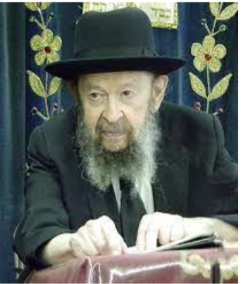

Yes. One is that when there’s an appointment to meet one of the bnei Torah, she should make it her business first to go to a beauty parlor. That’s a specific thing to do to be zocheh to marry a true ben Torah. It’s a pity so many girls don’t know that.

Another specific thing is to brush your teeth from the age of six on. And so when you’re going to meet that candidate and you’ll flash a smile, it shouldn’t be a row of crooked and decayed and dingy teeth. And so there are a lot of specific things a girl should do to be zocheh to marry a true ben Torah.

Now, the questioner expected me to say, to explain, what prayer she should add at the end of Shemoneh Esrei. Certainly, she should pray to Hakadosh Baruch Hu! But don’t forget that she has to do certain things that Hakadosh Baruch Hu wants her to do, things that are simple and direct in addition to all the other things.

Now I didn’t answer that question fully, but a little bit is also good.

*Reprinted from the current Eikev 5785 email of Torah Avigdor.*

**The Manna, the Bread from the Heavens and the**

**Evil Inclination**

**From the Teachings of the Lubavitcher Rebbe**

**Rabbi Menachem Mendel Schneerson, Zt”l**

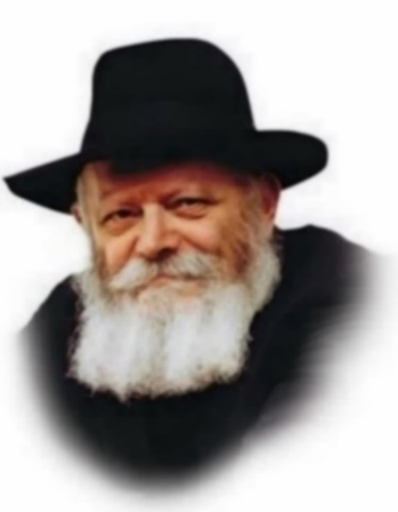

In this week's Torah portion, Eikev, Moses looks back upon the Jewish people's 40 years in the desert and mentions twice the manna they ate. Both times, Moses seems to imply that eating the manna was somehow distressing: "And He afflicted you and suffered you to hunger, and fed you with manna"; "[He] fed you in the wilderness with manna...that He might afflict you."

In fact, the Children of Israel complained bitterly over having to eat it. "But now our soul is dried away; there is nothing at all except this manna before our eyes." "Our soul loathes this light bread."

At first glance their complaint is surprising, as the Torah describes the manna as being delicious - "and its taste was like wafers made with honey." Our Sages comment further that the G-dly manna was unique in that the person eating it experienced whatever flavor he wished. Furthermore, the manna was completely digested, having no waste. How then could such a wonderful food be perceived as "torment"?

However, the Talmud explains that it was precisely these qualities that left the Jews with a sense of hunger. It was hard to get used to this "bread from the heavens" that had no waste and could taste like anything in the world. The Jews wanted regular bread, "bread from the earth." They longed for food that looked like what it was.

But the truth is that the Jews' resentment was motivated by the Evil Inclination. At first, the Evil Inclination draws a person into small sins, slowly working its way to more serious ones. So, it was with the Children of Israel: They started by complaining about the manna, then progressed to "crying among their families," implying transgressions in the area of family life.

The dynamics of the Evil Inclination never change, and even today, the Evil Inclination still chafes against "bread from the heavens." Symbolically, "bread from the heavens" stands for Torah and G-dly wisdom, while "bread from the earth" is secular, worldly knowledge. The Evil Inclination tries to make the Jew dissatisfied with his "bread from the heavens," and attempts to convince him that a steady diet of Torah will leave him hungry. "The Torah is endless," it whispers in his ear. "You can never learn it all; the more you'll learn, the more you'll see how infinite it is. Why not turn your mind to worldly matters? At least you'll get a feeling of fullness and satisfaction."

On an even finer level, the Evil Inclination tries to dissuade a Jew from studying Chasidut, the innermost part of Torah, which is also likened to "bread from the heavens." "Bread from the earth," the revealed part of Torah, is enough, it claims.

But the truth is the opposite. Because the Jew's essence is spiritual, he can never be satiated by worldly matters. Only Torah, and the innermost part of it, can make the soul feel full, for it is through Torah that the Jew connects to the Infinite.

*Reprinted from the Parshat Eikev 5762/2002 edition of L’Chaim, a publication of the Lubavitch Youth Organization in Brooklyn, NY. Adapted Likutei Sichot, Vol. 4.*

*\*\*\*\*\*\*\*\*\*\*\*\*\*\*\*\*\*\*\*\*\*\*\*\*\*\*\*\*\*\*\*\*\*\*\*\*\*\*\*\*\*\*\*\*\*\*\*\*\*\*\*\*\*\*\*\*\*\*\*\*\*\*\*\*\*\**

Blessed shall you be above all the nations; there shall not be a barren male or female among you (7:14) The Torah considers the Jewish soul the most precious commodity in the world. The proliferation of the Jewish people, therefore, is the highest blessing that can be bestowed upon them. (Rabbi Shimshon Refael Hirsch)

*Reprinted from the Parshas Eikev 5785 email of R’ Yedidye Hirtenfeld’s whY I Matter parsha sheet of the Young Israel of Midwood in Brooklyn, NY.*

**The Black Pastor Who Is Becoming a Proud Jew**

**By Sarah Pachter**



“You know you’re Jewish, right?”

Pastor Ricky Flowers Jr. was talking about basketball with his uncle when his uncle’s comment came out of nowhere.

“My uncle’s the type of guy who just randomly says crazy things, so I didn’t think much of it at the time. But later, when I was processing it, it sort of unraveled everything I thought I knew about myself.”

At the time, Ricky was a pastor at a mega-church, preaching on TV to over 30 million people. He led congregations and youth groups and was walking a path that, to most, seemed like success.

But Ricky felt pulled in a different direction. Something about Judaism always drew him in, even when he was a pastor.

**Drawn to Judaism**

As a child, his parents, practicing Christians, gave him a Bible and encouraged him to read it consistently. But while reading the Tanach, his focus drifted toward Judaism—not Christianity. He taught himself Hebrew and felt a strange sense of connection. In his final year of preaching, he even stopped saying the word “Jesus” and found himself stuttering whenever it came up.

“The last time I preached on camera, you won’t hear me use the word Jesus. I’d always stutter at that part. So eventually, I just started saying ‘God.’ I could never say the name ‘Jesus.’ Something inside me knew. In fact, my ex-girlfriend’s father once gave me a book on Judaism and said, ‘This just feels like you.’”

The church started to feel more like a business than a sanctuary. Finances were the key motivator, and Ricky felt increasingly disconnected.

“I tithed and gave ten percent to the church because I was a pastor. Then every time there was a holiday or pastor’s appreciation day, I had to donate again. We were expected to give $1,000 for the bishop’s birthday, another $1,000 for pastor’s appreciation... it became a financial burden.”

Then came the final straw: a financial scandal shook the church. Ricky, already disillusioned, stepped away.

“I was so turned off by all of it. When the scandal broke, I was like, ‘Y’all can keep this—I’m out.’”

**Homecoming**

After leaving the church, Ricky kept searching. He read the Quran, Buddhist texts, Hindu philosophy, and even taught himself to read ancient hieroglyphics. But something deeper kept tugging at him. He decided to call his uncle.

His uncle explained that their great-grandmother had been a Jewish woman from Portugal, who immigrated through the port of Virginia.

“It wasn’t a discovery—it was a homecoming,” Ricky said.

Ricky began observing on his own, keeping Shabbat and kosher. When he told his mother about his new practices, she responded not with judgment, but something unexpected.

“She told me that she used to pray the *Shema* over me while I was in the womb.”

Looking back, the signs had always been there. His grandfather had strong feelings about pork: “We could eat it on the porch, but once we stepped inside, pork was a no-go.”

“Judaism had always been there,” Ricky reflects, “waiting to be uncovered.”

“Both of my parents are Black,” Ricky says, “but we also have Portuguese roots through my great-grandmother. That’s how I traced my Jewish lineage.”

As he continued to observe Judaism and connect with the Jewish community, he realized he wasn’t alone.

“A lot of people don’t realize how deep Jewish roots run in Black communities,” he says. “I’ve met others with similar stories—especially once I started learning and connecting.”

At 36, Ricky decided to formally begin the process of conversion.

At first, he wanted to remain low-key: “I found a synagogue. I said, ‘I just wanna sit in the back and learn.’ But G-d had other plans.”

**Israel Activist**

One morning in Koreatown, Ricky was lying in bed when he heard shouting from a Palestinian rally. He grew upset. “They were talking about killing me, my friends, my people! I have family in Israel. I got so mad—I put on my kippah and my tzitzit, grabbed my Israeli flag, and drove into the middle of the protest, blasting the Israeli national anthem from my car speakers at full volume.

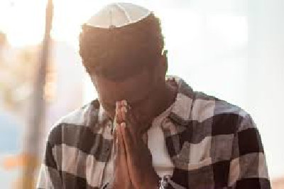

“People were yelling, but then they saw me—Black, wearing a kippah—and they got confused. Some just walked away. The video went viral.”

At a U.C. Berkeley event, Ricky stood in front of a huge sign that read: Black Jewish Zionist.

“People didn’t know what to do with that. They’d stop, stare, and ask me questions—some respectful, some aggressive. The most common question? ‘Do you even have a right to say that?’

“People ask how I can support Zionism as a Black man. I tell them, ‘Zionism is about self-determination. It’s about a homeland. You believe in Black liberation, right? Why don’t Jews deserve the same?’ That usually gets them thinking.

“People want to box you in. They see a Black face and assume you can’t be Jewish or pro-Israel. But I refuse to fit into anyone’s box. My life is proof you can be both—and proud.”

He once wore a sign: “I’m a Black Zionist Jew. Ask Me Anything.” One angry woman screamed at him but ended up hugging him in tears after a 17-minute conversation.

“I tell people: Love isn’t just soft. Love is action. Love is accountability. Love is showing up, even when it’s hard. For me, that means standing with Jews. Standing with Black people. Standing with anyone who’s ever been told they don’t belong.”

When people ask him, "What is Zionism?” Ricky responds, "Do you believe you have the right to exist and walk freely without fear of being attacked for wearing a shirt someone dislikes, or for having a cross on your backpack because you're Christian?" They responded, "Yes, of course." Ricky said, "Well, that's what Zionism is. I believe I have the right to exist, to walk freely without fear of attack or harassment. I believe my family and I should have a place to live without worrying about these things."

**Love Is Real**

Ricky’s approach comes from love. He is now the face of the organization *Love Is Real*(a play on the words Love Israel), a group combating Jew-hatred, racism, and homelessness. Despite the heavy issues, the group of 500+ members has experienced little negativity.

They set up booths on college campuses around the U.S. giving away free merchandise and sharing their mission. People stop by not just for t-shirts but for conversation. Most people don’t even realize it’s a Jewish organization. Ricky believes he’s making a huge *Kiddush Hashem,*sanctifying G-d’s Name.

Their college campus groups host festivals, concerts and gatherings, making loving Jews fun and hip and inclusive. Ricky believes it’s a more effective way to combat antisemitism.

Not everyone receives the message. One woman spewed hatred at Ricky once he realized he was Jewish. Ricky said, “How can someone say they love, when all they focus on is hatred toward one group?”

Ricky is no stranger to hate. He grew up in a deeply racist neighborhood in Ohio.

“I got hit with a bat when I was eight—split my head open for being Black. I got jumped by the KKK in 10th grade. Cops have pulled guns on me more times than I can count. And now that I’m openly Jewish, I get even more hate than before. The things people say… the looks I get… just for existing,” says Ricky.

“I hear the most heinous things that people are saying, calling me combinations of words I’ve never even heard of before, but I'm so used to it. Growing up in Ohio helped prepare me for what I'm dealing with now. I thought that was going to be the worst of it, but I'll tell you there ain't nothing harder than being Jewish and being Black. I think G-d put me in this exact position for a reason.

Ricky believes that love is going be the way we beat this. “When I was on the ground yelling at people—it didn’t work. But when you come at people with love, it does all the work for you. It highlights how much the other side isn’t doing that.”

Ricky Flowers is living proof that embracing your truth—with courage, love and conviction—can shake the world for good.

*Reprinted from the current website of aish.com*

**Thoughts that Count**

**for Our Parsha**

*And you shall keep and do them [plural]...and He will love you and bless you [singular] (Deut. 7:12-13)*

"And you shall keep and do them" is in the plural, as it refers to keeping the Torah's commandments, which all Jews must do equally. "And He will love you and bless you" is in the singular, as it refers to the reward a Jew receives for his observance, which is entirely individual. Although all Jews keep the same mitzvot, they do so with different levels of enthusiasm, devotion and motivation; thus they are given varying degrees of reward. (Kli Chemda)

*Now Israel, what does the L-rd your G-d ask of you except to fear G-d (Deut. 10:12)*

"People are strange," Rabbi Chanoch of Alexander used to say. "They beg and plead that G-d should give them 'fear of heaven,' when this is something that is entirely in the individual's control. Yet when it comes to livelihood, they imagine that they are in charge."

*And you shall eat and be sated. (Deut. 8:10)*

The Maggid of Mezritch once asked a wealthy man what he eats every day. "Bread and salt, Rebbe, like a poor man," was his reply. The Maggid rebuked him and told him to eat meat and drink wine every day as wealthy men were accustomed to do. Later, when the Maggid's disciples asked for an explanation, he said: "If a rich man eats meat and drinks wine every day, then he will realize that a poor person needs at least bread and salt. If, however, he eats bread and salt, he will think that his poor neighbor can make do with stones!"

*And to serve Him with all your heart (Deut. 11:13)*

Rashi explains that this verse refers to the service of the heart, namely prayer. Reb Yisroel of Ruzhin used to take a long time over his prayers; Reb Shalom of Belz would recite his prayers hastily. On this, one of their contemporaries commented that both of them cherished every word of the prayers: the former loved them so much that he could not bring himself to part with them, while the latter-for the same reason-could not restrain his eagerness to make them his. (A Treasury of Chasidic Tales)

*Reprinted from the Parshat Eikev 5762/2002 edition of L’Chaim*

***GEMS FROM whY I Matter***

And it will be if you forget the Almighty, your G-d (8:14) We find in the Midrash that the word "vehayah" refers to joy. What joy could there possibly be in forgetting Hashem? The Kotzker Rebbe said that this verse can be understood by dividing the words differently: "If you forget to be in a state of joy," that is, if you forget the vehayah which refers to joy, this will cause you to forget Hashem. If someone lacks joy, he will find it difficult to appreciate Hashem. Hence joy is one of the forty-eight tools for acquiring Torah. Lack of joy leads to many faults and difficulties. When in a state of joy, you have a greater appreciation for Hashem and all that He has given you. (Growth Through Torah)

They have quickly turned aside from the way... they have made a molten image (9:12) Not every transgression causes a Jew to immediately abandon the straight and narrow and completely forfeit his connection to the Jewish people. The sin of idol worship, however, is so elemental and consequential that the very first step in its direction tears the Jew away from everything that is holy. As it states in the Talmud (Chulin): "An apostate who commits idolatry thereby rejects the entire Torah." (The Rebbe, Reb Heshel)

“You should know in your heart that just as a father will chastise his son, so Hashem, your GD, chastises you.” (8:5) How do we explain situations where it appears that Hashem is distancing himself from us? And we see this even by people who appear to us to be great Tzadikim. A parent’s job is to teach a child. We should observe what happens when a person attempts to teach his child how to walk. As the child takes a few steps, the parent moves further away. In this way the child tries to walk more and get closer to the parent. So too - Hashem wants us to grow and learn. As Hashem distances Himself from us - we should be attempting to ‘walk’ closer to Hashem. (Mezritcher Maggid)

**A Small Polish Torah Scroll**

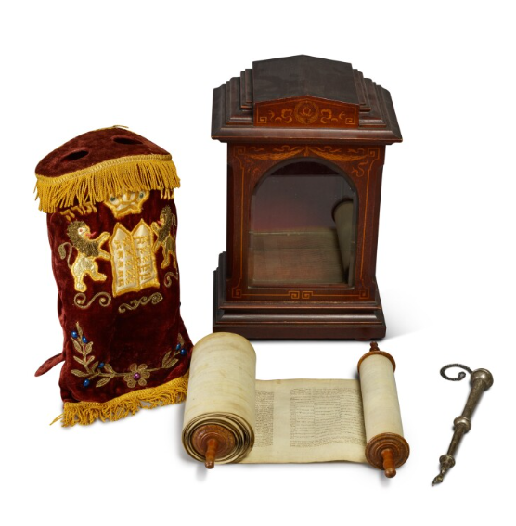

*Reprinted from the 2024 Sotheby’s Important Judaica Catalogue, Lot #11*